PRACTICAL 6 GP

CREATE A BLANK PROJECT AND IMPORT GIVEN PACKAGES

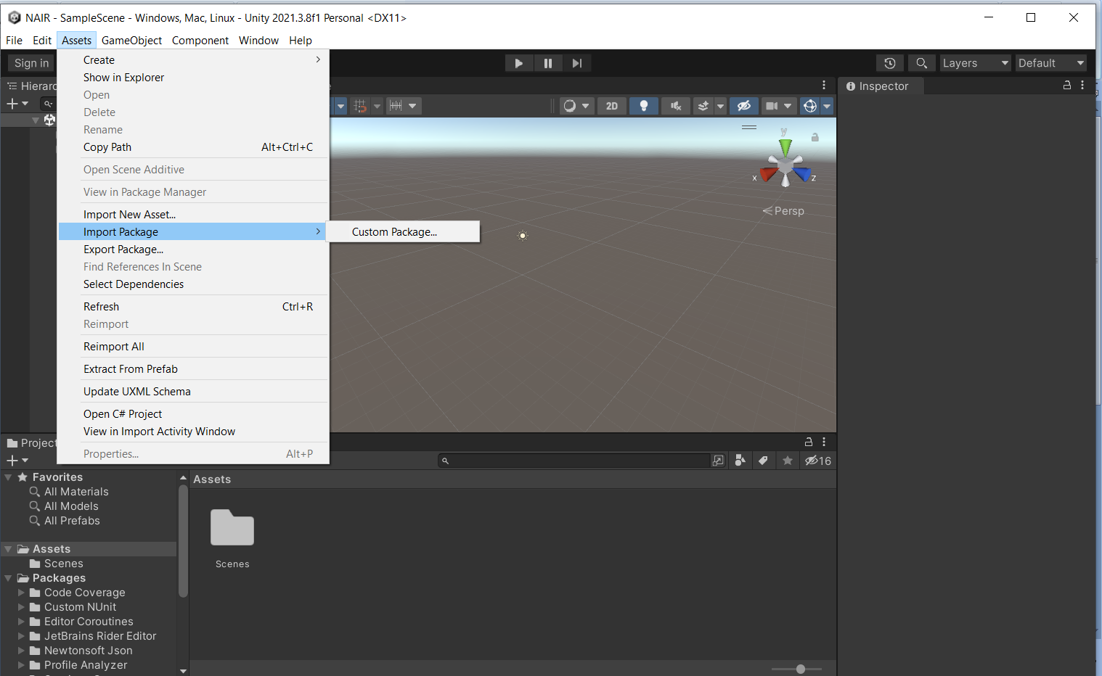

2] Select the package file

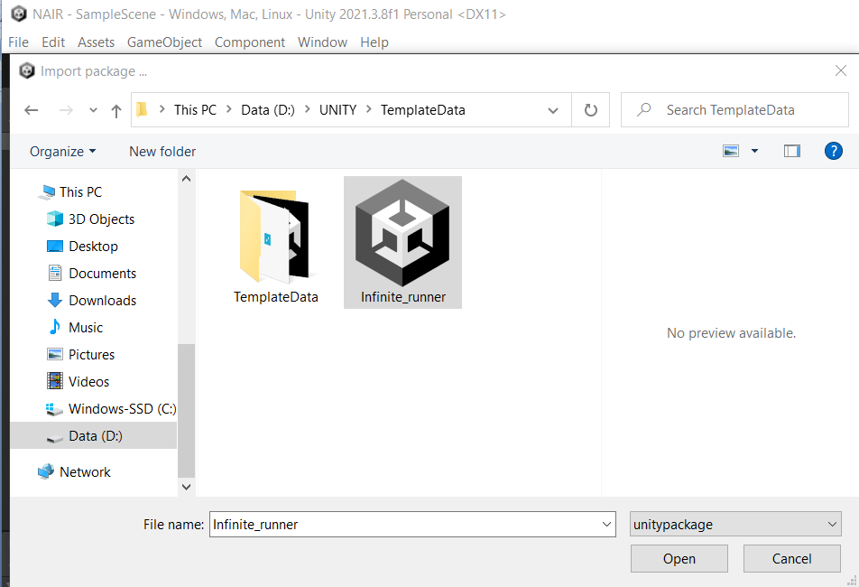

3]IMPORT THE PACKAGE

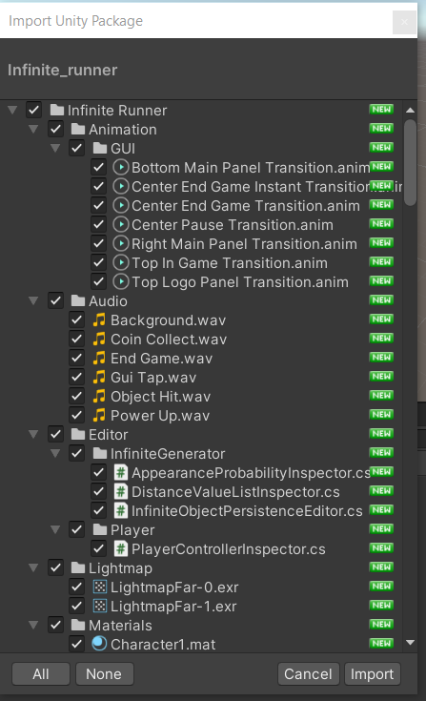

4] GO TO ASSET > INFINITE RUNNER > SCENE>

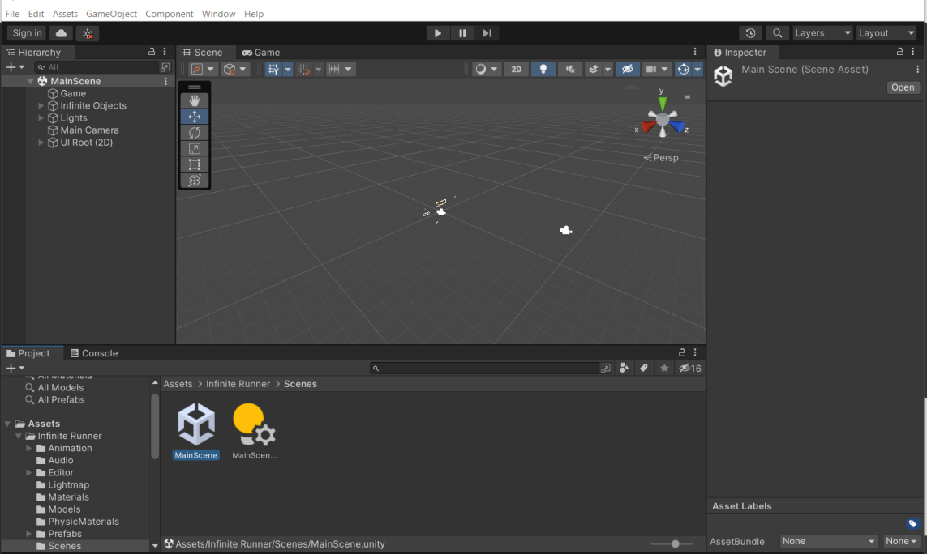

5] RUN THE APPLICATION/GAME

